Report
Date | 22 September 2026
Team ID
Project Name | Comprehensive Analysis of Online Learning Engagement and Student Performance
Maximum Marks | 5 Marks

A report is a comprehensive document that provides a detailed and structured account of data analysis, findings, and insights. It is typically used for in-depth analysis, documentation, and communication of results. Reports are suitable for a diverse audience, including decision-makers, analysts, and stakeholders who need a comprehensive understanding of the data.
Designing a report in Power BI involves connecting to data sources, creating visualizations like charts and graphs, customizing their appearance and interactivity, organizing them logically on the canvas, formatting elements for consistency and clarity, and optionally creating dashboards for a summarized view. Throughout the process, it's essential to consider the audience's needs and ensure the report effectively communicates insights from the data. Finally, iterate based on feedback to continually improve the report's design and usefulness.
Comprehensive Analysis of Online Learning Engagement and Student Performance
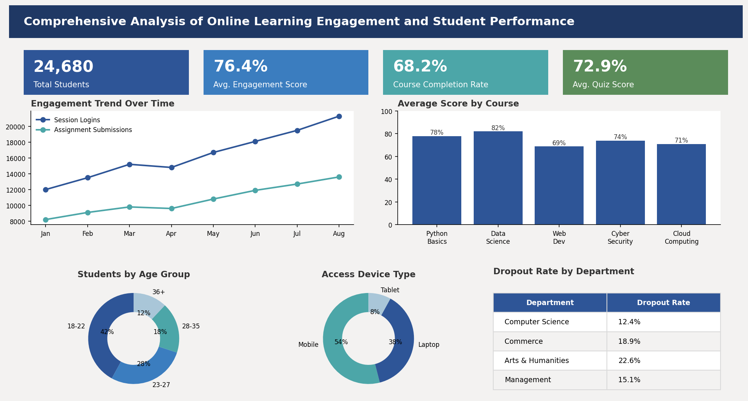
Observations drawn from reports in Power BI can provide valuable insights into student engagement patterns and performance trends.

1. Trends Over Time
Analyze how key metrics (e.g., course enrollments, session logins, assignment submissions) change over different time periods (weekly, monthly, per semester) to identify growth patterns or seasonality

2. Performance Comparison
- Compare performance across different categories, such as courses, departments, or student cohorts, to determine which areas are excelling or underperforming.

3. Student Segmentation
- Assess demographic and behavioral data (age group, course type, device used, time spent) to understand student segments and tailor engagement strategies accordingly.

4. Goal Achievement
- Measure progress against established KPIs (e.g., course completion rate, average quiz score, engagement rate) to assess whether learning outcomes are being met.
Example:
- Engagement Trend:
  - Session logins grew steadily from 12,000 in January to 21,300 in August, while assignment submissions rose from 8,200 to 13,600 over the same period, showing consistently rising engagement.
- Performance by Age Group:
  - Among enrolled students, the 18–22 age group makes up the largest share at 42%, suggesting this demographic engages most consistently. This could support the case for age-targeted course design and pacing.
- Departmental Disparities:
  - The Arts & Humanities department shows the highest dropout rate at 22.6%, indicating potential barriers in that segment. Targeted interventions could improve overall completion rates.
- Overall Enrollment and Completion:
  - A total of 24,680 students enrolled, with an overall course completion rate of 68.2% and an average quiz score of 72.9%. The Data Science course recorded the highest average score at 82% and should be studied for replicable engagement strategies.
Conclusion
The analysis shows that student engagement on the platform has grown consistently across the year, with the 18–22 age group and mobile users forming the largest and most active segments. While the overall completion rate of 68.2% reflects healthy engagement, the notably higher dropout rate in Arts & Humanities points to a need for targeted retention efforts — such as revised pacing, additional mentoring, or course-format adjustments — in that department. Replicating the design choices behind higher-performing courses like Data Science across other courses could help raise average scores platform-wide.

